AIM: To implement the K-Means Clustering algorithm using Python to group students into three clusters based on their hours studied and marks, and visualize the clusters and their centroids using a scatter plot.

ALORITHM:
- Start.
- Import the required libraries: Pandas, Matplotlib, and K-Means from Scikit-learn.
- Load the student dataset from data.csv.
- Remove extra spaces from the column names.
- Select Hours studied and Marks as input features.
- Create a K-Means clustering model with 3 clusters.
- Fit the model to the selected data.
- Predict the cluster labels for each student.
- Add the cluster labels to the dataset.
- Display the clustered student data.
- Plot the students using a scatter plot with different colors for each cluster.
- Display the cluster centroids using red X markers.
- Add the axis labels, title, and legend to the graph.
- Display the final clustering diagram.
- Stop.

OUTPUT:
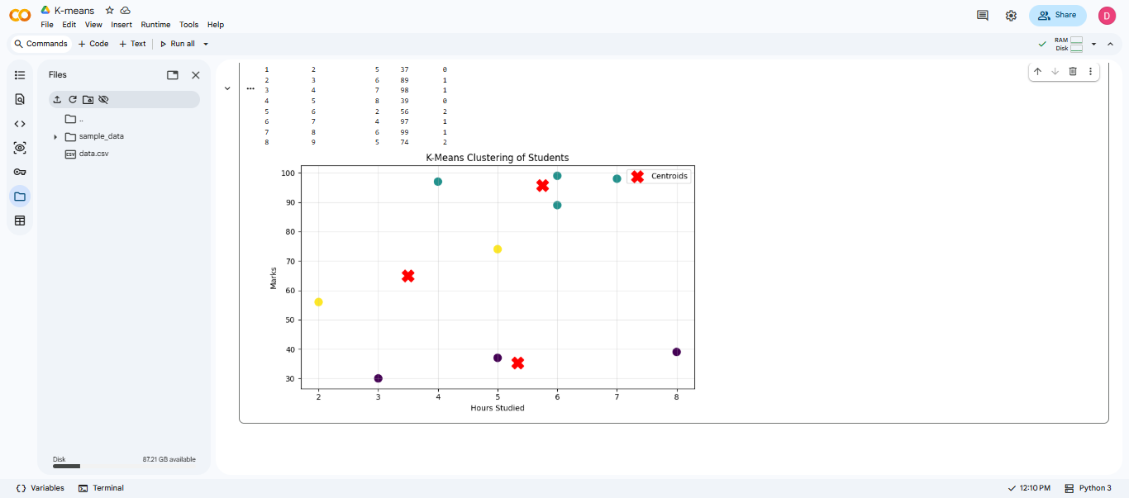

RESULT: Thus, the K-Means Clustering algorithm was successfully implemented to group students based on their study hours and marks.

